NORTHERN VIRGINIA MENTAL HEALTH FOUNDATION

EFFECTIVENESS REPORT
FOR 2018

Prepared by Joan Durman, Ph. D.
February 2019
Northern Virginia Mental Health Foundation
Effectiveness Report
For 2018

For low-income individuals living with serious mental illness, the Northern Virginia Mental Health Foundation (also known as NVMHF or the Foundation) is a welcome resource. As these individuals cope with daily living issues, they often look to the NVMHF to fund support services that helps them achieve their wellness goals. The Foundation offers three ways to help individuals:
- an annual Wellness and Recovery Conference
- the micro-grant program that provides funding for a myriad of treatment supports: housing expenses, medical care or equipment, employment training, dental care, transportation to medical care, and additional needed services that are not funded elsewhere
- payment of medical co-pays for individuals in treatment who are not current with their fees and about to lose access to primary medical care.

Annual Wellness and Recovery Conference
For the past 25 years, the Foundation (and its precursor The Woodburn Foundation) has been instrumental in partnering with other organizations to champion mental health awareness within Northern Virginia. In 2018 the Foundation sponsored and coordinated the 2018 Wellness and Recovery Conference focused on suicide prevention. The conference drew 218 attendees, including 121 individuals in mental health treatment whose conference fee was paid by the Foundation and other mental health providers.

Micro-grant Program, including Medical Co-Pays
Micro-grants are provided in a way that respects the individual’s privacy and dignity. Perhaps the first level of effectiveness is demonstrated in the grant process. A clinician makes a request for funding on behalf of the individual, providing a description of need but no identifying client information. This process not only complies with federal HIPPA requirements, it also guarantees that the request is consistent with the individual’s treatment plan. The clinician is an advocate for the individual, guiding the request through the approval process.
The Foundation is a funder of last resort. By the time a request reaches the Foundation, the individual and the clinician have usually sought other funding sources; have sometimes arranged for the Foundation to share the costs with other organizations; and have at times obtained discounts for services that the individual needs. With everyone working together, resources are leveraged in order to provide complete, not merely partial, results.
The micro-grant process may be seen in Figure 1.
Figure 1. Micro-grant Process

The Foundation process assures that it only funds bona fide requests, defined as only services that the individual’s clinician deems necessary and that are consistent with the treatment plan created by the individual and the clinician to guide the individual’s service success. The Foundation has set procedures for assessing the need for service and for assuring that the service provider or product is reasonable. The Foundation Board includes a licensed clinical psychologist with extensive clinical experience. This Board member reviews all requests for micro-grants, obtains and analyzes feedback from the Foundation Board members, and communicates the funding decision to the clinician. Although the Foundation is not directly responsible for the individual’s wellbeing, it is an essential intermediary in the treatment process, responsible for funding but not providing selected services.
For example, a clinician requested a micro-grant for an individual who had an abscess tooth but no funds for dental service. Obtaining dental treatment was part of the individual’s treatment plan. The Board member who is an experienced clinician reviewed the request, received feedback from the Foundation Board members, and recommended that it be approved. The Foundation then sent a check directly to the clinician so that the individual could receive treatment for her abscessed tooth. The Foundation funded but did not directly provide the service. Under the terms of the micro-grant process, the Foundation effectively helped the individual receive appropriate dental care.

Assessing the Foundation’s Service Effectiveness
The process by which the Foundation administers its micro-grants is consistent with good management practices and complies with the steps in a standard effectiveness measurement system. It includes the following steps, as shown in Figure 2:
Figure 2. Standard Effectiveness Measurement System
The Foundation uses this system in its micro-grant process to determine which requests it will fund.
Problem Identification: The clinician, on behalf of the individual, prepares a micro-grant application in which is documented an issue affecting the individual’s ability to receive a service that is part of the treatment plan. The clinician requests funding to purchase this service.
Priority Setting: The Foundation determines if the request is consistent with the Foundation’s mission and its requirement that it be the funder of last resort for goods and services that enable an individual to achieve or progress toward an established treatment goal.
Inputs: If the Foundation approves the micro-grant, the Foundation will provide funds to the clinician for the requested service.
Activities: The Foundation notifies the clinician of the micro-grant award so that the clinician may support the individual to receive the service.
Outputs: The clinician delivers the requested services or products.
Outcomes: When the individual receives the requested service or product, a step in the individual’s treatment plan is completed. The treatment plan is constructed to help the individual achieve treatment goals. The individual informs the Foundation of their progress toward their treatment goals through the clinician who initiated the request.

In 2018 the Foundation supported 158 low-income individuals who received public mental health services. The number of requests received by the Foundation is higher than the number of persons served because in a small number of cases, an individual received more than one grant. Through its micro-grant program, the Foundation helped these individuals receive one or more of a variety of treatment supports, including:
- Medical Services for 90 individuals where the Foundation paid co-pays for medical services received through the Neighborhood Health Program. Ninety-six (96) requests were approved.
- Specialty Healthcare for 11 individuals, including payments for medical devices, transportation for health care, and home health care. Eleven (11) requests were approved.
- Dental Services for 8 individuals who needed major dental treatment to improve their health and employability. Nine (9) requests were approved.
- Housing for 9 individuals to assist them in achieving independent housing goals. Nine (9) requests were approved.
- Other Support Services for 36 individuals who participated in educational programs, social skill development, recreation, and other activities to improve their wellness. Forty-two (42) requests were approved.

The Foundation received 181 micro-grant requests in 2018, of which 92% were approved and funded. Less than 2% (N=3) were not approved by the Foundation; in addition, for various reasons clinicians withdrew 6% (N=11) of the requests. Over half of the micro-grant requests (53%) were for payment of medical co-pays. The distribution of requests is shown in the following table.
Table 1. Distribution of Micro-grant Requests
Supports | Number of Requests | Number Requests Withdrawn | Number of Request Not Approved | Number of Requests Granted | Percent of All Requests | Percent of Request Approved within Each Category
Medical | 96 | 0 | 0 | 96 | 53.1% | 100%
Specialty Healthcare | 14 | 2 | 1 | 11 | 7.7% | 78.6%
Dental Services | 12 | 2 | 1 | 9 | 6.6% | 75.0%
Housing | 11 | 2 | 0 | 9 | 6.1% | 81.8%
Other Support Services | 48 | 5 | 1 | 42 | 26.5% | 87.5%
Totals | 181 | 11 | 3 | 167 | 100%

Small Grants Are Meaningful to Low-Income Individuals Receiving
Pubic Mental Health Services

Micro-grants by definition are small. They are requested by clinicians on behalf of individuals receiving public mental health services and used by individuals to achieve some of their treatment goals, those for which they have no other funding. Since the Foundation provides funds for services but does not actually deliver the services, it relies on clinicians and individuals to provide feedback about the service or product. The Foundation offers the following feedback about services and products it funded in 2018 as examples of the effectiveness of its micro-grant program.

Medical Services

for 90 individuals where the Foundation paid co-pays for medical services received through the Neighborhood Health Program

“NVMHF has provided individuals who receive CSB [Fairfax-Falls Church Community Services Board] services support over the past few years. With the partnership of NVMHF [the Foundation], a group of individuals were able to come to the CSB and receive their Primary Care services by a doctor from Neighborhood Health. NVMHF helped these individuals by paying for their co-pay balances through Neighborhood Health when no other financial avenue was able to be used. Because of this important partnership, those clients will be able to have access to primary care services that are affordable and come back for their follow up needs. We sincerely thank you for the continued support on this important partnership and collaboration.”

Pouneh Zeraat, M.Ed., CSAS; Health Integration Manager
Fairfax-Falls Church Community Services Board – Be Well Program
This micro-grant covered co-pay for 6 individuals at a cost of $1,181.80.

Specialty Healthcare

for 11 individuals, including payments for medical devices, transportation for health care, and home health care

“Ms. A. applied for a grant on April 27 to cover the cost of eyeglasses. She received the eyeglasses three weeks after and she’s been using them since. She has glaucoma and she needed the eyeglasses to relieve the pressure in her eyes. Your generosity helped my client have better vision and less stress related to her glaucoma symptoms.

On behalf of my client and myself, I want to thank you for your generosity that helps support, honor and uplift the lives of our clients.”

Samar Chwairy, RN, QMHPA, QSACM
Fairfax-Falls Church Community Services Board
Gartlan Center for Community Mental Health
This micro-grant paid for eyeglasses that cost $108.95.

“Mr. B. was able to meet with his podiatrist and receive a diagnosis for his ongoing foot problems. He received medication and recommendations for additional support to reduce pain. He has been able to follow up with is primary care physician for ongoing treatment. Since the pain has improved, Mr. B has been able to work full time at a print shop and is attempting to obtain a second part-time job. He has reported that although his foot still bothers him at times, it is much improved from pretreatment status.”

Nicole Brandon, Case Manager
This micro-grant paid for office visit to podiatrist that cost $230.

“Ms. C. benefited from receiving the funds provided as evidenced by her report of significant relief related to the outstanding medical bill getting paid. She verbalized feeling like she did “the right thing” by seeking treatment when she did and that doing so may have prevented a more serious medical situation and admission to the hospital. She also verbalized that receiving funds made her feel like other people validated “my worth and that people shouldn’t feel guilty about not having insurance or going to the ER when you really are sick.”

Gloria Larson-Jadali
Mid-County Intensive Case Management Program
This micro-grant paid $1,307 for hospital fee.

Dental Services

for 8 individuals who needed major dental treatment to improve their health and employability
“I wanted to give you an update on the $555 check that was provided to Ms. C for Affordable Dentures. I had the privilege of being able to accompany the client to the facility today for her impressions this morning and to pick up the final product this afternoon. She was thrilled with the quality and fit of the dentures. We spent the car ride home planning meals that she will be able to eat again. She asked me to send along the following message: ‘Please let them know that I am thankful from the bottom of my heart, and that I am finally able to smile as I say it.’ As always, your assistance and support has made a tremendous difference in the quality of life for this individual. Thanks you for your continued efforts!”

Nicole M. Brandon, MA; Behavioral Health Specialist
Behavioral Health Outpatient Services
Fairfax-Falls Church Community Services Board
Gartlan Center for Community Mental Health
This micro-grant paid $555 for dentures.

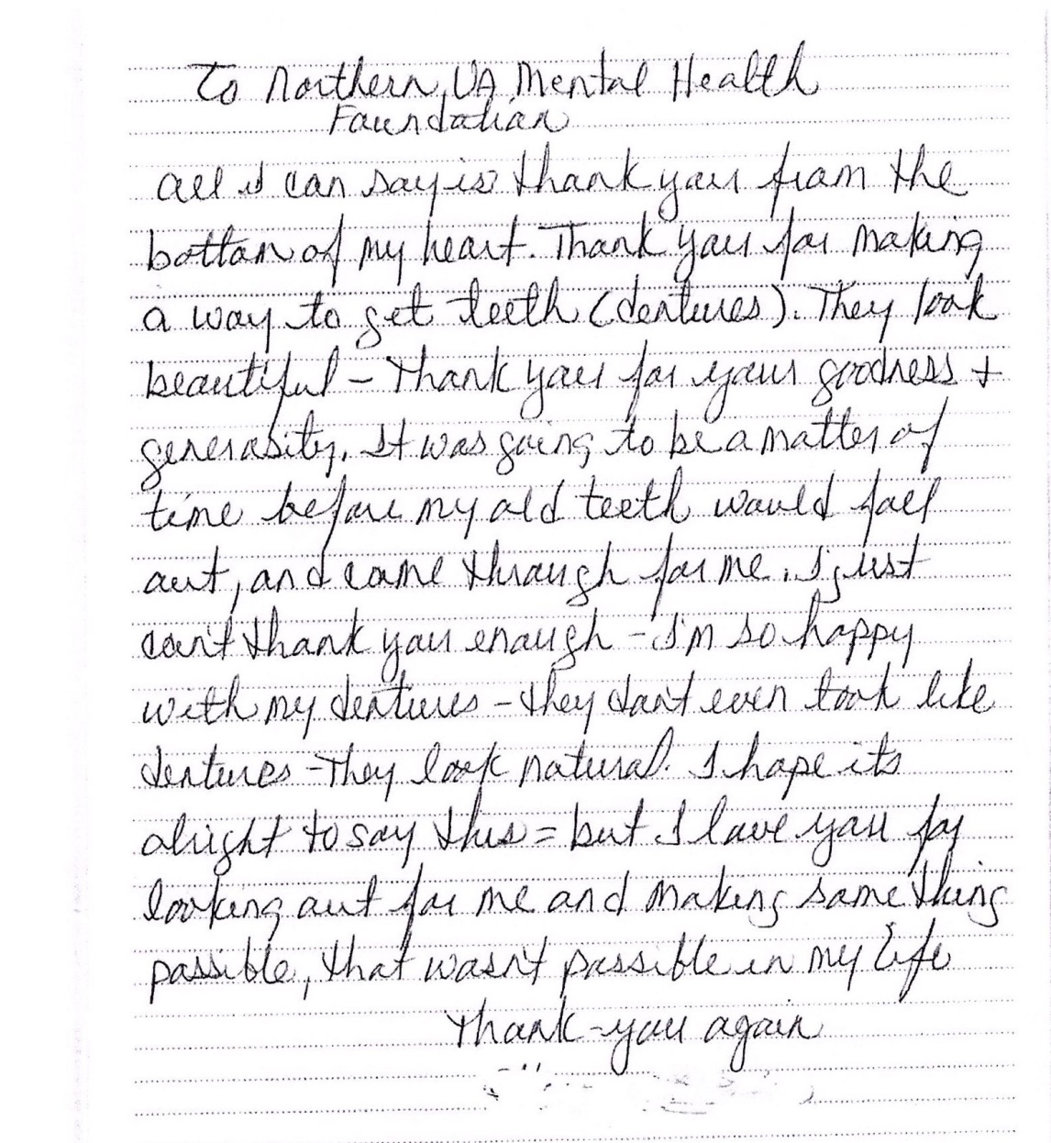

This micro-grant paid $1,465 for teeth extractions and dentures.

Housing
for 9 individuals to assist them in achieving independent housing goals
“I had submitted a grant request, which was accepted, for a client I am working with, who owed her former apartment $167.37 (now in collections). The client is currently homeless and this owed money is a barrier for housing programs. The client was very discouraged as this question came up in her interviews with a housing program (Bridging Affordability).
When I received the email that the grant was approved, I informed the client on the phone that the grant had been approved. She was able to notify her FACETS housing worker of this and also the housing program that she was being considered for.
I met with the client today. . . She informed me that she was approved for the Bridging Affordability program. . . She can now proceed with a clean slate . . .This individual is very motivated to break this cycle of homelessness and this grant has really boosted her resolve.
Andrea Kyriazi, M. ED, CSAC, RYT; Adult Behavioral Health Outpatient Clinician
Fairfax-Falls Church Community Services Board
Merrifield Center
This micro-grant paid $167.37 in back rent.

Other Support Services

for 36 individuals who participated in educational programs, social skill development, recreation, and other activities to improve their wellness

“This memo is to share the impact and gratitude from the client recipient of the recent donation of an Amazon gift card in the amount of $508.00. The gift card was for the purchase of a new mattress and box spring with frame and sheets. The client had been sleeping on the floor for over one and a half years. The client has serious mental illness and trauma from throughout her adulthood. She has a treatment goal to improve her mood lability, decrease her paranoia and decrease her hypervigilance/fearfulness. She is the mother of a high school senior and takes her daily responsibilities to him very seriously. Client has a need to have a good night’s sleep consistently to contribute towards this goal and her recovery. Chronic sleep issues had become a part of life for the client and caused much suffering.
As a result of the donation received by NVMHF, the client has been sleeping much better. As each item was being received to the home by Amazon delivery, the client would call me to update and was filled with a joy I had not seen in her before. Another member of her treatment team described her as ‘glowing.’ The client stated to me in person in session after she was sleeping on the new bed ‘I feel no strain on my body. I feel high up and like I’m on a cloud. It is comfortable and helps me to get a better night’s sleep. I finally feel safe.’
Please accept this letter as a note of gratitude and appreciation on behalf of the client. This has changed her life in a daily way that makes parenting and her recovery work more successful.”
Cynthia Miller, Case Manager
Fairfax-Falls Church Community Services Board
Gartlan Center for Community Mental Health
This micro-grant paid $508 for mattress, box spring, frame and sheets.

“This grant from NVMHF enabled the client to have a professional cleaning service for her home. Once the home was clean, it received pest control treatment and bedbugs were eliminated. She was able to pass inspection, maintain her Housing Choice Voucher, and remain in her home of 8 years where she lives with her husband and 9 year-old daughter.”
Rebecca B Waxman, LCSW; Behavioral Health Senior clinician
Fairfax-Falls Church Community Services Board, Merrifield Center
This micro-grant paid $ 725 for cleaning services and pest control treatment
to eliminate bedbugs.

“This grant assisted this person in continuing to go to the rec center for swimming. It has benefitted her in continuing to focus on her health. A few years ago she had a heart attack, so fitness is a key component in her maintaining healthy living and keeping her heart strong. She continues to work with our Be Well program in assisting her in healthy living as well.”
Eileen Yates
Fairfax-Falls Church Community Services Board
Gartlan Center for Community Mental Health
This micro-grant paid $147 for a recreation center pass
“Thank you for funding the $229 computer class. . .The individual is linked to DARS but has not yet received funding for training. Prior to taking the class he was feeling stuck in his goal of building employment skills and entering the workforce. The individual successfully completed the computer class. The individual found the course helpful and believes he will use the information in his future employment.”
Emma Hacker, LCSW
Behavioral Health Senior Clinician
Supported Housing Program
Fairfax-Falls Church Community Services Board
Gartlan Center for Community Mental Health
This micro-grant paid $229 for a computer class

